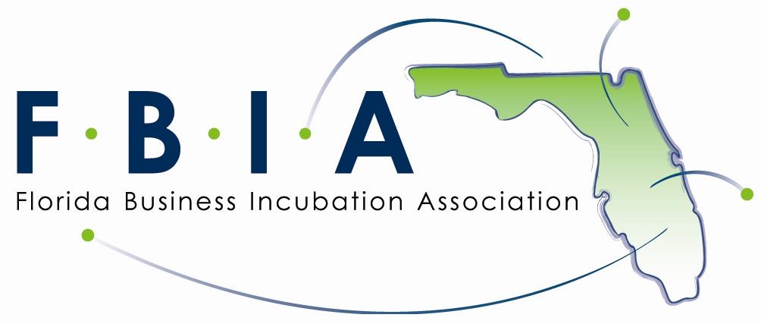


The Florida Business Incubation Association and National Business Incubation Association conference scholarship

Application
This scholarship is available to first-time NBIA conference attendees only and is limited to the cost of the early bird registration for the conference. Up to two scholarships will be provided for the 2006 conference.

To apply for this scholarship opportunity, please complete the application form send it to: jamathew@mail.ucf.edu or fax it to 407-420-4849 Attn: Julie, no later then Feb 28th, 2006.

Name
Address 1
Address 2
City
Province/State
Country
Postal Code
Email address
Telephone number | ( )
Fax number | ( )

Please describe your interests in business incubation and how you feel you can benefit from this scholarship.

